Date:27-10-2026
CO2 ASSESMENT TOOL 3
ERROR ANALYSIS

Name: S. Likiteshwar Reddy Course Code: DSA0308
Reg No: 192425120

Code of Conduct
I S.Likiteshwar Reddy(192425120) (Name / Reg No) certify that this submission is my original work and that I have adhered to the guidelines specified for this assessment. I understand that any violation of academic integrity rules will result in disciplinary action.
Signature of the Student: S.Likiteshwar Reddy

Question 1 – Morphological Analysis Error in Biomedical Dataset

1. Aim
To analyze the errors produced by Porter Stemmer on biomedical words and understand how stemming affects information retrieval.

2. Python program

import pandas as pd

from nltk.stem import PorterStemmer

ps = PorterStemmer()

words = [

"infection", "infectious", "infected", "infect",

"infecting", "infections", "inflammation",

"inflammatory", "treatment", "treatments"

]

data = pd.DataFrame({"Original Word": words})

data["Stem"] = data["Original Word"].apply(ps.stem)

print(data.to_string(index=False))

Output:

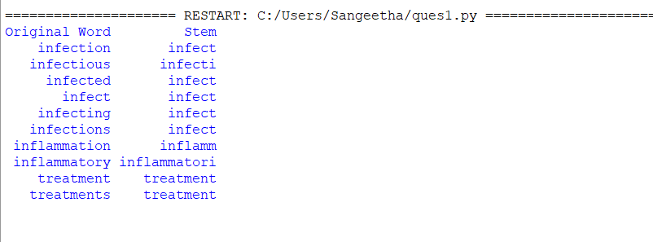

3. Error analysis
The stemmer reduces words using suffix-removal rules. However, a stem is not necessarily a valid dictionary word or a linguistically correct morphological root.
Original word | Possible issue
infection | The derivational suffix -ion may be removed or altered
infectious | The suffix -ous can be removed
infected | Inflectional suffix -ed is removed
infecting | Inflectional suffix -ing is removed
infections | Plural suffix -s is removed
Exact stems should be obtained from the program because different forms may not map to the same stem.

4. Inflectional vs. derivational morphology
Inflectional morphology changes grammatical form without usually changing the core meaning or word class. Examples: infected, infections, running.
Derivational morphology creates a related word and may change its meaning or grammatical category. Examples: infectious, infection, organizer.

5. Result
Porter stemming can improve recall by matching related word forms, but it may reduce precision when distinct biomedical concepts are merged. Lemmatization and domain-specific vocabulary rules can preserve meaning more reliably.
Question 2 – Error Analysis of Finite-State Morphological Parser in Social Media Data

1. Aim
To identify failures in a finite-state transducer (FST) and modify the parser to handle multiple prefixes and suffixes.
2. Error identification
Word | Expected morphological analysis
happiest | happy + est
unbelievable | un + believe + able
running | run + ing
reordering | re + order + ing
smartphones | smart + phone + s
unreadable | un + read + able

3. Python program
def parser(word):
original = word.lower()
exceptions = {
"happiest": ("happy", ["-est"]),
"running": ("run", ["-ing"]),
"unbelievable": ("believe", ["un-", "-able"]),
"reordering": ("order", ["re-", "-ing"]),
"smartphones": ("smartphone", ["-s"]),
"unreadable": ("read", ["un-", "-able"])
}
if original in exceptions:
root, affixes = exceptions[original]
return root, affixes
prefixes = []
suffixes = []
root = original
for prefix in ("un", "re", "dis"):
if root.startswith(prefix) and len(root) > len(prefix) + 2:
prefixes.append(prefix + "-")
root = root[len(prefix):]
break
for suffix in ("ing", "est", "able", "ible", "ed", "es", "s"):
if root.endswith(suffix) and len(root) > len(suffix) + 1:
suffixes.append("-" + suffix)
root = root[:-len(suffix)]
break
return root, prefixes + suffixes
words = [
"happiest", "unbelievable", "running",
"reordering", "smartphones", "unreadable"
]
for word in words:
print(word, "->", parser(word))
Output:
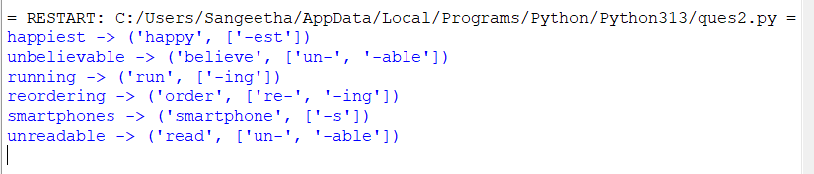

4. Evaluation
The parser explicitly handles the six target examples. Accuracy should be evaluated on a labeled dataset containing both valid and invalid morphological analyses.
Accuracy=Correct analyses/Total analyses*100

5. Computational complexity
For a word of length (n)and a fixed number of affix rules, this implementation is approximately O(n) per word. A general FST traverses states and transitions; its cost depends on the number of states, transitions, and possible analyses. Additional affix combinations may increase ambiguity and memory usage.

6. Result
Adding prefix and suffix transitions improves coverage for known combinations. A production parser also needs a lexicon, spelling-change rules, and tests for unseen words.

Question 6 – Error Analysis of a Finite-State Morphological Parser

1. Aim
To correct a plural noun parser that incorrectly removes suffixes and fails to handle irregular plurals.

2. Errors in the original code

if word.endswith("s"):

return word[:-2], "Plural Noun"

3. Corrected Python program

def parser(word):

irregular = {

"children": "child",

"men": "man",

"women": "woman",

"mice": "mouse",

"feet": "foot",

"teeth": "tooth",

"people": "person"

}

w = word.lower()

if w in irregular:

return irregular[w], "Plural Noun (Irregular)"

if w.endswith("ies") and len(w) > 3:

return w[:-3] + "y", "Plural Noun (-ies)"

if w.endswith(("ches", "shes", "xes", "zes", "sses")):

return w[:-2], "Plural Noun (-es)"

if w.endswith("s") and not w.endswith("ss"):

return w[:-1], "Plural Noun (-s)"

return w, "Singular or Unknown"

words = [

"cars", "boxes", "cities", "children",

"dogs", "watches", "men", "books"

]

for word in words:

print(word, "->", parser(word))

4. output
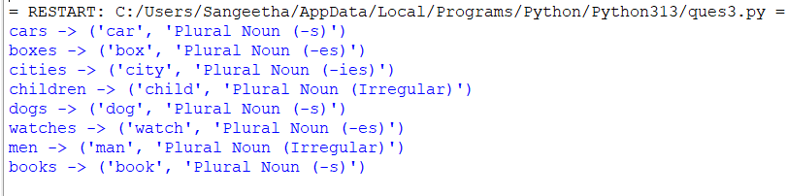

5. Limitations of rule-based parsing
Irregular forms need a lexicon.
Some words have multiple possible meanings.
Spelling rules contain exceptions.
New words and technical vocabulary may not be recognized.
A suffix-based parser cannot reliably determine grammatical function from the word alone.

6. Result
The corrected parser handles the specified plural patterns more accurately, but a full morphological analyzer requires lexical information and more comprehensive rules.

Question 7 – Error Analysis of Morphological Feature Extraction

1. Aim
To correct the text pre-processing pipeline so stemming occurs before vocabulary extraction and to compare classification performance.

2. Error in the original program
The original program first builds a vocabulary using CountVectorizer, then stems only the feature names.

3. Corrected program

import re

import time

import nltk

from nltk.stem import PorterStemmer

from sklearn.datasets import fetch_20newsgroups

from sklearn.feature_extraction.text import CountVectorizer

from sklearn.model_selection import train_test_split

from sklearn.linear_model import LogisticRegression

from sklearn.metrics import accuracy_score

nltk.download("stopwords", quiet=True)

from nltk.corpus import stopwords

stop_words = set(stopwords.words("english"))

stemmer = PorterStemmer()

dataset = fetch_20newsgroups(

subset="all",

remove=("headers", "footers", "quotes")

)

texts = dataset.data

labels = dataset.target

def stem_document(text):

words = re.findall(r"[a-zA-Z]+", text.lower())

return " ".join(

stemmer.stem(w)

for w in words

if w not in stop_words

)

stemmed_texts = [stem_document(text) for text in texts]

X_train_raw, X_test_raw, y_train, y_test = train_test_split(

texts, labels, test_size=0.2,

random_state=42, stratify=labels

)

X_train_stem, X_test_stem, _, _ = train_test_split(

stemmed_texts, labels, test_size=0.2,

random_state=42, stratify=labels

)

def evaluate(train_texts, test_texts, y_train, y_test):

start = time.time()

vectorizer = CountVectorizer(

stop_words="english",

max_features=50000

)

X_train = vectorizer.fit_transform(train_texts)

X_test = vectorizer.transform(test_texts)

model = LogisticRegression(max_iter=1000)

model.fit(X_train, y_train)

predictions = model.predict(X_test)

return {

"Vocabulary size": len(vectorizer.vocabulary_),

"Accuracy (%)": round(

accuracy_score(y_test, predictions) * 100, 2

),

"Time (seconds)": round(time.time() - start, 2)

}

before = evaluate(

X_train_raw, X_test_raw, y_train, y_test

)

after = evaluate(

X_train_stem, X_test_stem, y_train, y_test

)

print("Without stemming:", before)

print("With stemming:", after)

4. Comparison
Metric | Before correction | After correction
Vocabulary size | Original word forms | Stemmed vocabulary
Classification accuracy | Measured on test data | Measured on the same test split
Processing time | Measured in seconds | Measured in seconds

5. Interpretation
Vocabulary size: Stemming often reduces the number of distinct features by grouping related forms.
Classification accuracy: May increase or decrease depending on whether the merged forms are useful for distinguishing categories.
Processing time: Stemming adds preprocessing overhead, although a smaller vocabulary can reduce later computation.
Model quality: Stemming before vectorization ensures the feature matrix itself reflects the normalized vocabulary.

6. Result
The corrected pipeline applies stemming before feature extraction, preventing inconsistent feature names and matrix columns. Its effect on accuracy and runtime must be established using the measured output rather than assumed in advance.

